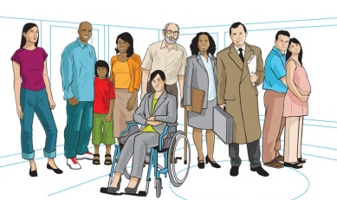
Marazion Surgery
Patient Participation Group

Monday 22nd April at 6.00pm
Marazion Community Centre
for patients registered at Marazion Surgery

A presentation by PAPYRUS
Suicide Prevention
Awareness, Resources and Knowledge
- To raise awareness of suicide and suicide prevention.
- To promote PAPYRUS – What we do, how you can help and how we can help you.
- To develop HOPE for a suicide-safer community.
- To understand the importance of self-care.

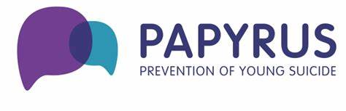
Please bring cash for refreshments, raising money for PAPYRUS and for our raffle, raising money for Marazion Surgery.

PAPYRUS Prevention of Young Suicide - www.papyrus-uk.org

